Assignment - 2
Course Number - ACS-2913-001
Course Name - Software Requirements Analysis and Design
Instructor – Victor Balogun
Students Name - Manmeet Singh [ St id- 3177236]
Daljeet Singh [ St id- 3169763]

1. Identifying the Use Cases: -
(a)Table with identified use cases: -
USE CASE NAME | ACTORS | BRIEF USE CASE DESCRIPTION
Personalised language lessons | User (Learner) | The app provides personalize language lessons based on the person’s performance which AI adjust in real time.
Pronunciation Practice | User (Learner) | User can practice pronunciation by speaking the words and AI can hear them and provide feedback.
Vocabulary Builder | User (Learner) | A User can learn new vocabulary through topic-based exercises, or they can expand language knowledge.
Listening Comprehensions | User (Learner) | User can listen to the comprehension to enhance their listening skills.
Writing and translating | User (Learner) | User can write the sentence and translate it which will help them to understand the language more accurately.
Idioms | User (Leaner) | App contains the special section in which it provides the idioms and meaning of that language which helps the user can understand them.
Daily practice and practice streaks. | User (Learner) | User can set the timer for the practice session and app can send the notification at that time.
Offline lesson download | User (Learner) | User can download the lessons and watch them anytime.
Quizzes | User (Learner) | User can do the quiz to test the skills what they have learned during the lesson.
Daily language goal tracker | User (Learner) | User can set daily goals, the app tracks the progress and sets the reminder.
Analyse User Progress | AI | AI monitor user performance data, such as quizzes.
Provided feedback | AI | After the completion of quiz AI evaluates the responses and feedback.
Recommendations | AI | The AI provides the personalized recommendation based on the user interest.
Adjust difficulty | AI | AI analysis user strengths and weakness and adjust the difficulty as their needs.
Add new lessons | Manager | The manager uploads new lessons and content.
User’s Account | Manager | Manager can create, update and delete the user’s account if he wants.
Review and approved AI based recommendations | Manager | The manager can adjust and review the recommendations provided by the AI.

(b) Use Case Diagrams: -
1. Language lessons:

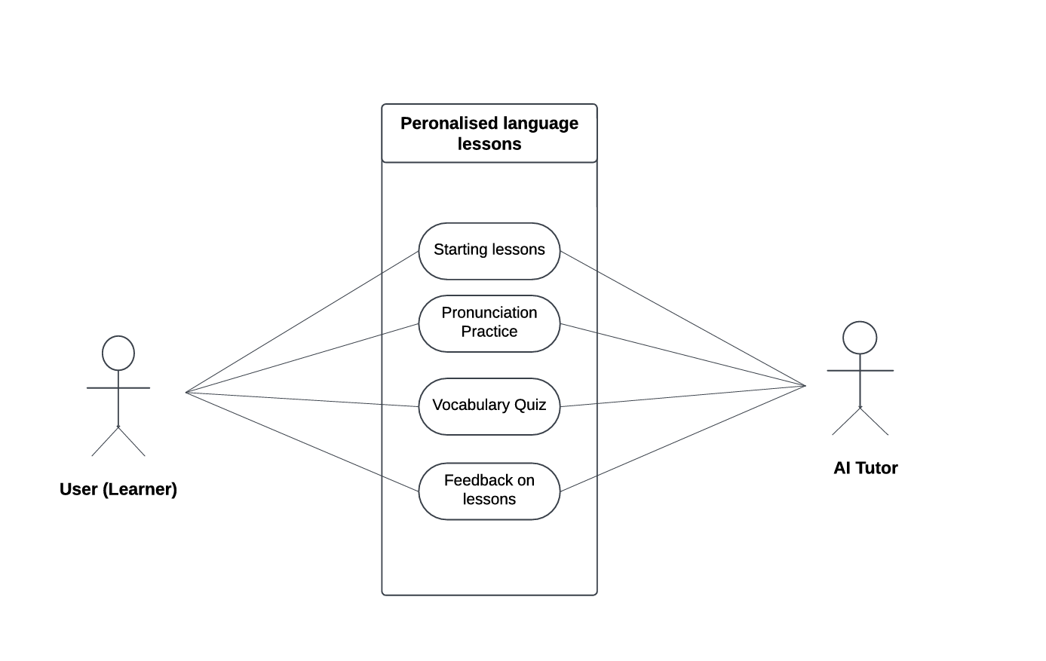
This diagram focuses on the primary functions of the learning module, where users interact with lessons, vocabulary, and pronunciation practices.

2. User Progress Tracking:

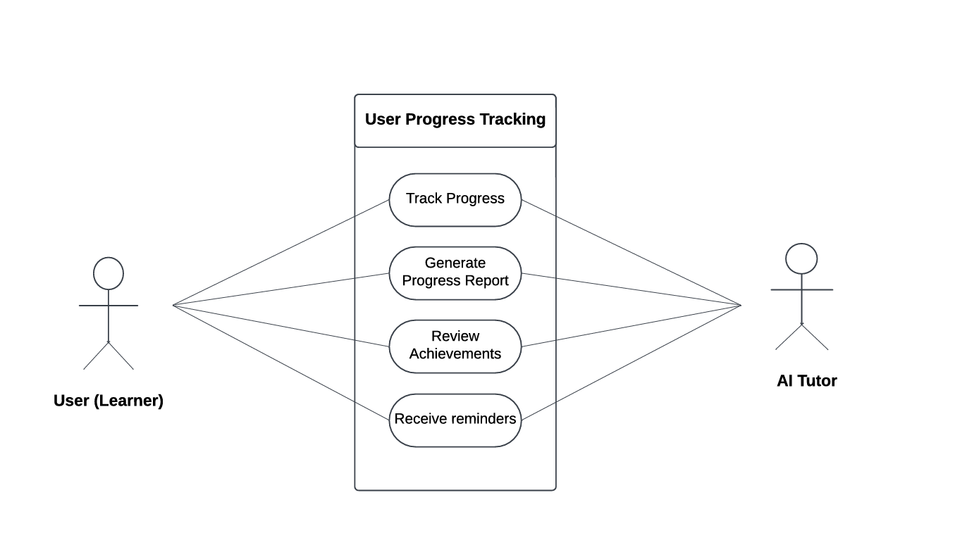
This diagram shows how the app tracks and reports user progress, allowing users to review their achievements and reports.

3. User Management:

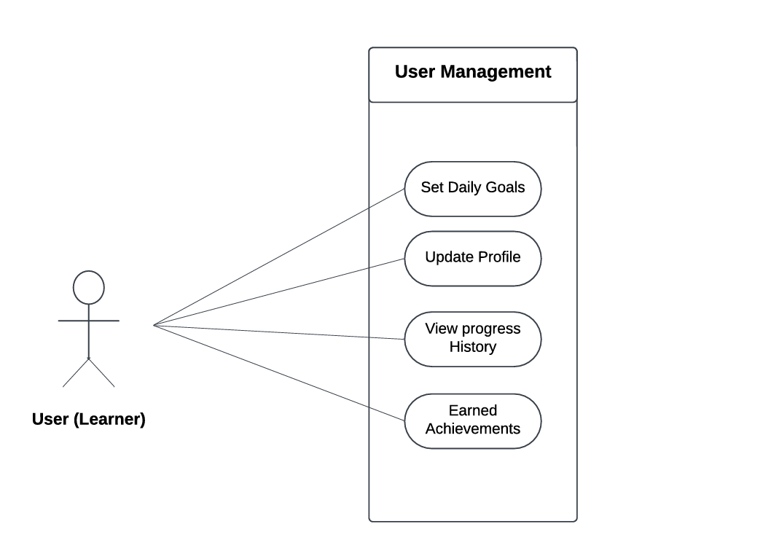
This diagram highlights the user account management features, focusing on settings, goal management, and achievement tracking.

4. Subscription:

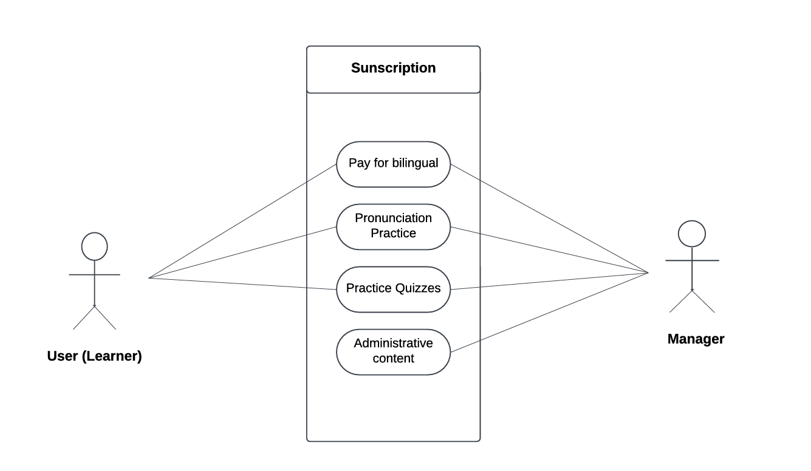
This diagram highlights the user subscriptions, focusing on subscription pay, administrative content, and more advanced feature which are available after subscription pay such as practice quizzes and pronunciation practice.
2. List on Nouns identified and Notes regarding them: -

Identified Noun | Notes on including Nouns as a Things to Store
User | Yes, essential to store user detail, language and learning preferences.
Lesson | Essential to store content tracking and user progress.
Language | User needs to select the language which they want to learn, it is essential thing and need to store by the app.
Nickname | A type of name given to user by the user, might not need to store permanently.
Progress | Work and lessons done by the user, need to store.
Feedback | Feedback provided to the user performance needs to be stored to track user performance over time.
Vocabulary | It is necessary to store vocabulary items for lessons and quizzes.
Grammar Rule | Yes, it is important to store the grammar rules.
Pronunciation practice | No need to store the sentences spoken by the user during the lessons.
History | Additional content provided to users. Optional to store as part of lesson content.
Language goals | Goals are set by the user need to be stored to provide them the daily notification.
Performance | Need to store user performance by storing the result of all quiz to set the difficulty of the next quizzes.
Achievements | Represents the accomplishment of the course and badges provided to the user.
Notification | Sends the daily reminder/message to the user.
Quizzes | A type of practice exam which need to store to records the user performance.
Speaking | Speaking helps the user to better pronounce the language.
Leaderboard | May be temporarily generated to show user rankings but doesn’t require long-term storage.

2. (b) List of all the “Things” which system store the information: -
- User - The learner using the app to study a new language.
- Lesson - A learning module covering specific language skills or topics.
- Quiz - An assessment to test the user’s understanding of lesson content.
- Feedback - Comments and suggestions to help users improve based on their performance.
- Progress Report - A summary of the user's advancement in the app.
- Vocabulary - Words and phrases the user is learning.
- Grammer Rule - Language rules provided to improve user’s sentence structure.
- Language Goals - Objectives set to guide the user's language learning journey.
- User Performance Report - A detailed report on the user’s learning progress and outcomes.
- Achievement - Milestones reached as users progress in learning.
- Notification - Alerts to remind and inform users about their learning activities.

3. Domain Model class Diagram: -
- User related entities:
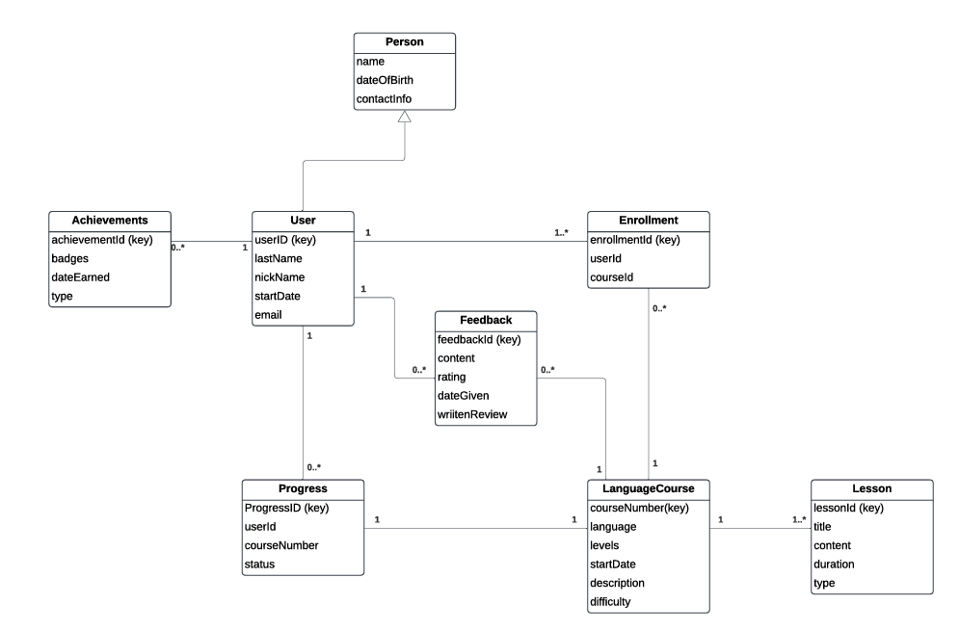
1. Person to User (1 to 1): Each Person has one User account.
2. User to Achievements (1 to 0..*): Each User can earn multiple Achievements.
3. User to Feedback (1 to 0..*): Each User can provide multiple Feedback entries.
4. User to Progress (1 to 0..*): Each User has multiple Progress records to track course advancement.
5. User to Enrollment (1 to 0..*): Each User can enroll in multiple courses.
6. Enrollment to LanguageCourse (0..* to 1): Each Enrollment links a user to one LanguageCourse.
7. Progress to LanguageCourse (0..* to 1): Each Progress record tracks a user's status in a LanguageCourse.
8. LanguageCourse to Lesson (1 to 1..*): Each LanguageCourse includes multiple Lessons.
9. Feedback to LanguageCourse (0..* to 1): Each Feedback can relate to one specific LanguageCourse.

- LanguageCourse related entities:
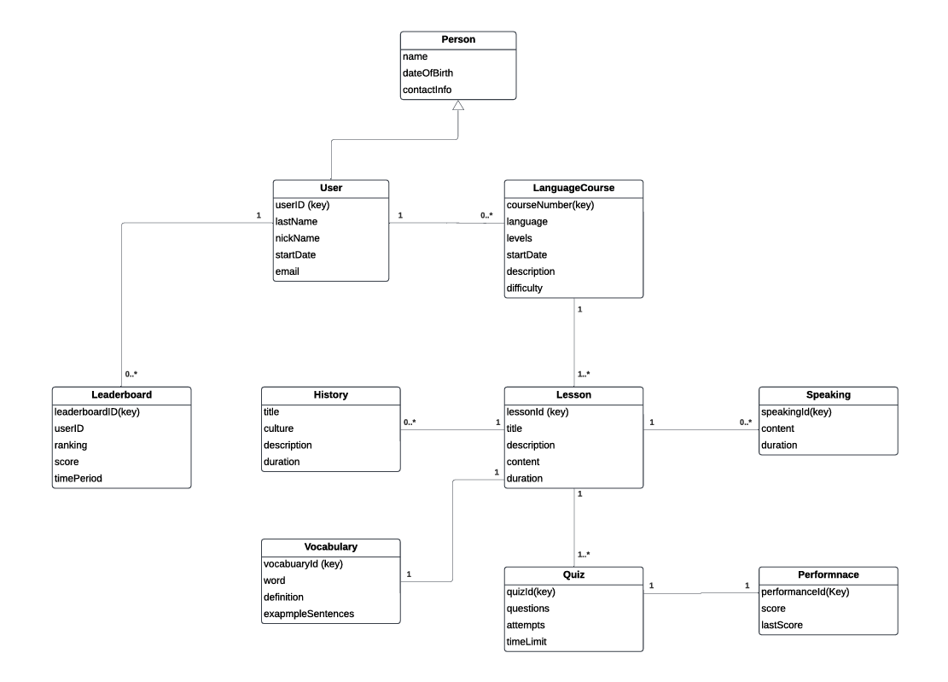
1. Person to User (1 to 1): Each Person has one User account.
2. User to LanguageCourse (1 to 0..*): Each User can enroll in multiple LanguageCourse instances.
3. LanguageCourse to Lesson (1 to 1..*): Each LanguageCourse consists of multiple Lesson entries.
4. Lesson to Speaking (1 to 0..*): Each Lesson can include multiple Speaking activities.
5. Lesson to Quiz (1 to 1..*): Each Lesson has multiple associated Quiz activities.
6. Quiz to Performance (1 to 1): Each Quiz has one Performance record tracking results.
7. User to Leaderboard (1 to 0..*): Each User can appear on multiple Leaderboard entries.
8. Lesson to Vocabulary (1 to 1): Each Lesson includes specific Vocabulary content.
9. Lesson to History (1 to 0..*): Each Lesson can cover multiple History entries (cultural aspects).

4. State Machine Diagram: -
The three main classes that can be modelled as a state machine diagram are-
- Language Learning Lesson Class –
The class represents learner using the system demonstrating the states and transitions
States | Transition Exit
Open | Choose language
Not Found | Begin
Language Selected | Starting Lesson
Start Lesson | Going in progress
In progress | Completion
Completed | Feedback
Feedback Submitted | Restart Or Exit

Final State Machine Diagram –

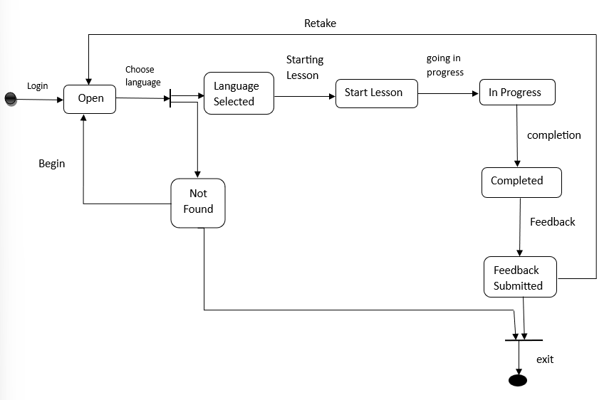

- Module Class-
The class models the learner using the modules of system.

States | Transition Exit
Open | Select Module Type and difficulty level
Selected | Going to Start
Start Module | Going In Progress
In progress | Completion
Submitted | Evaluating
Graded | Retaking Or Exit

Final State Machine Diagram -

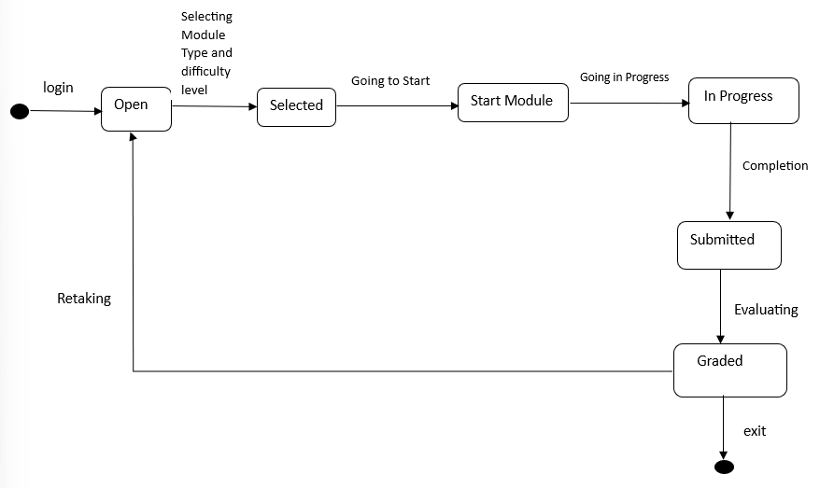

- Pronunciation Session Class-
The class demonstrates how user uses pronunciation session.

States | Transition Exit
Open | Starting session
Started | Listening
Listened | Evaluating
Evaluated | Generating Feedback
Feedback Given | Retake or Exit

Final State Machine Diagram-

